**Multimedia Communications**

EEE408

Lab 2 - report

Name: Cong Yin

ID Number: 1715471

**Introduction**

RCNN is a milestone, which use CNN for target detection and proposed by RBG. It can realize the transformation of target detection, with the help of favorable feature extraction and classification performance of CNN. The procedure of R-CNN as shown in the figure.1.

**Theoretical knowledge**

**Regions with Convolutional Neural Network Features (R-CNN)**

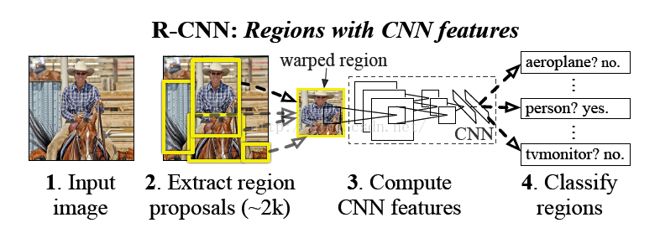

**Figure.1 Four steps of R-CNN algorithm**

The process of R-CNN algorithm can be decided into four steps

(1) Generate the region proposal: one image generates 1K to 2K region proposal (using Selective Search method).

(2) Feature extraction: this step is a standard procedure of CNN, that extract features for each region proposal. According to the convolution and pooling, which based on the input. And then, get the output, which is fixed dimension.

(3) Judge the classification: sent the features to each classification of SVM classifier to determine whether it belongs to their classification.

(4) Amend the location: use the returning machine for amend the location of region proposal carefully.

**Selective Search**

Selective Search have several main ideas:

(1) A segmentation method is used to divide the image into small areas (1k~2k).

(2) Check the existing small area and merge the two adjacent areas with the highest likelihood according to the merger rules. Repeat this step until the whole image is merged into one area.

(3) Output all the areas that once existed and named candidate areas.

**Spatial Pyramid Pooling (SPP Net)**

There are two characteristics of Spatial Pyramid Pooling. Firstly, it combined with the method of Spatial Pyramid to realize how to input the scale by CNNs. As a general rule, the fully connected layer and classifier will be connected after the CNN and they all need the fixed input size. So, we have to use “crop” or “warp” for process the input data. There is data loss or geometric distortion will be caused by these pretreatments. The first contribution of SPP Net is to add the theory of Spatial Pyramid to the CNN, and then, it realizes the multiscale input of data. As shown in the figure.2, the SPP layer has been added between convolutional layer and fully connected layer. At this time, the input of the network can use any scale. In SPP layer, the filter of each pooling is adjusted according to the input, while the output scale of SPP is always fixed.

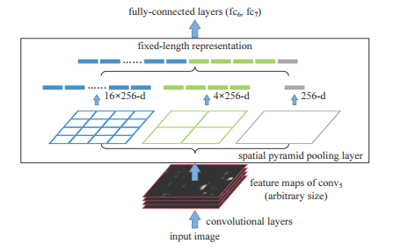

**Figure.2 A network structure with a spatial pyramid pooling layer. Here 256 is the filter number of the ${conv}_{5}$ layer, and ${conv}_{5}$ is the last convolution layer**

The second characteristic is extracted only one convolution feature from the original graph. In R-CNN, each region proposal will become to uniform size by “resize”, and then, used that as input to CNN, which is inefficient. So, SPP Net optimizes this shortcoming. There is only convolution of the original graph, which is made to get the feature map of the whole graph. Finally, find the mapping patch of each region proposal on feature map, and use this patch as the convolution feature of each region proposal for input into the SPP layer and other layers, which after SPP layer. It will save a large amount of time.

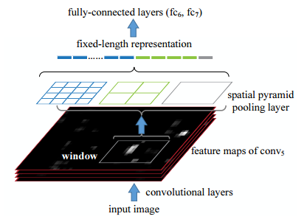

**Figure.3** **pooling features from arbitrary windows on feature maps. The feature maps are computed from the entire image. The pooling is performed in candidate windows.**

**Fast R-CNN**

An input image and multiple regions of interest (RoIs) are input into a fully convolutional network. Each RoI is pooled into a fixed-size feature map and then mapped to a feature vector by fully connected layers (FCs). The network has two output vectors per RoI: SoftMax probabilities and per-class bounding-box regression offsets. The architecture is trained end-to-end with a multi-task loss.

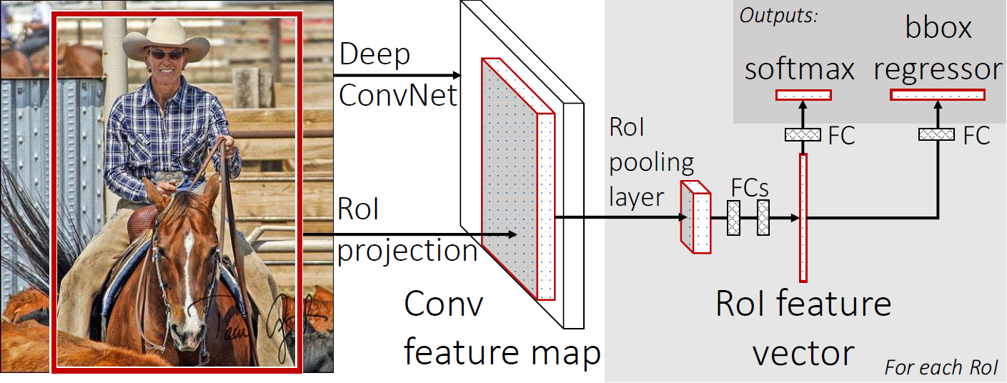

**Figure.4 Fast R-CNN architecture.**

The process of Fast R-CNN algorithm can be decided into five steps

(1) Generate the region proposal: one image generates 1K~2K region proposal (using Selective Search method).

(2) According to the CNN, we can get the feature map   
(3) Find the patch, which belongs to each region proposal in the feature map. And regard as characteristic of convolution of each region proposal. Finally input that into SSP layer and every layer, which before SPP layer.

(4) Use classifier for judge whether or not these characteristics belongs to a specific category, which was extracted by region proposal.  
(5) For any specific category, use returning machine to adjust its position farther

Compare with Fast R-CNN, R-CNN have several shortcomings. The main shortcomings of that is each region proposal will go through the CNN all alone. It will take a large amount of time. So, for solve this problem, Fast R-CNN make the sharing of convolution layer. And now, not every region proposal will go through the CNN. Instead, input a complete picture and get the characteristics of each region proposal in fifth volumes. The first step of the original method is get the region proposal (1k to 2k). And then, go through the CNN and get the characteristics of each region proposal. Finally, classification and regression. The first step of Fast R-CNN is input the complete picture. And then, go through the CNN and get the characteristics of each region proposal. Finally, classification and regression.

**Table.1** **performance improvement**

|  |  |  |
| --- | --- | --- |
|  | R-CNN | Fast R-CNN |
| Training time | 84 hours | 9.5 hours |
| Speedup | 1x | 1x |
| Test time per image | 47 seconds | 0.32 seconds |
| Speedup | 1x | 1x |

**Faster R-CNN**

The process of Faster R-CNN algorithm can be decided into four steps

(1) According to the CNN, we can get the feature map  
(2) input the characteristics into RPN and get the feature information of region proposal  
(3) Use classifier for judge whether or not these characteristics belongs to a specific category, which was extracted by region proposal.  
(4) For any specific category, use returning machine to adjust its position farther

There are some problems in Fast R-CNN, and it is very time-consuming to find all region proposal by using selective search. Therefore, in order to solve these problems, it is very effective to add a neural network, which can extract the edges in Faster R-CNN. In other words, the work of finding the region proposal is also given to the neural network. And this kind of neural network, which to do such a task is called Region Proposal Network (RPN). The specific practice of that can be divided into two steps. Firstly, put RPN in the back of the last convolution layer. And then, according to the training by RPN can get the region proposal.

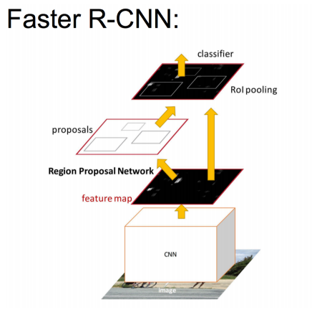

**Figure.5 Faster R-CNN architecture**

**Table.2** **performance improvement**

|  |  |  |  |
| --- | --- | --- | --- |
|  | R-CNN | Fast R-CNN | Faster R-CNN |
| Test time per image (with proposals) | 50 seconds | 2 seconds | 0.2 seconds |
| Speedup | 1x | 25x | 250x |
| mAP (VOC2007) | 66.0 | 66.9 | 66.9 |

**Region Proposal Network(RPN)**

RPN is a sliding window in the feature map, the main implication of that is build a special neural network and use it for classification and regression. A Region Proposal Network (RPN) takes an image (of any size) as input and outputs a set of rectangular object proposals, each with an objective score.

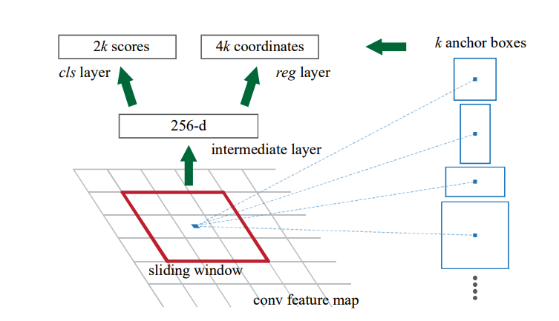

**Figure.6 RPN architecture**

**Task 1**

**Problem description**

Please describe the 2 key components in the Fast R-CNN framework: the RoIPooling layer and the loss functions in the framework. (20%)

**Results and analysis**

**RoIPooling (Region of Interest) layer**

The RoIPooling (Region of Interest) layer is the simplified version of Spatial Pyramid Pooling. There are several layers in the Spatial Pyramid Pooling that the reason why it named "Pyramid"(bins=n). The number of each window (block) is different, the ROI layer contains only one layer in Fast-RCNN, which can be seen as a special case of SPP (bins=1). The RoI was designed for meet the requirements of Classification and regression. Because region proposals have different sizes and shapes. The input of this layer is characteristic mapping, which number is N. And a group of RoI, which number of RoI is R and R>>N. Feature map comes from the last convolution layer. Each ROI is an array ([n, r, c, h, w]), (r, c) is the coordinate in the top left corner of certain region. And (h, w) is high and wide, n is the index of the feature map ($n∈\left\{0, … ,N-1\right\}$). In the RoIPooling layer, the corresponding feature map are generated according to each r, c, and w of RoI. Because each feature map of RoI is ultimately connected to the FC layer. So, the size of feature map, which is the output from each region is the same. Therefore, it just need only one bin and the size of bin is adaptive, which depend on the size of RoI.

**Multi-task loss**

A Fast R-CNN network has two sibling output layers. The first outputs a discrete probability distribution (per RoI), $p= \left(p_{0},⋯,p_{k}\right)$, over $K+1$ categories. As usual, p is computed by a SoftMax over the $K+1$ outputs of a fully connected layer. The second sibling layer outputs bounding-box regression offsets, $t^{k}=\left(t_{x}^{k},t_{y}^{k},t_{w}^{k},t_{h}^{k}\right)$, for

each of the K object categories, indexed by k. in which $t^{k}$ specifies a scale-invariant translation and log-space height/width shift relative to an object proposal.

Each training RoI is labeled with a ground-truth category u and a ground-truth bounding-box regression target v. The multi-task loss L on each labeled RoI to jointly train for classification and bounding-box regression:

$$L\left(p,u,t^{u},v\right)=L_{cls}\left(p,u\right)+λ[u≥1]L_{loc}(t^{u},v)$$

in which $L_{cls}\left(p,u\right)=-logp_{u}$ is log loss for true category u.

The second task loss, $L_{loc}$, is defined over a tuple of true bounding-box regression targets for category u, $v = (v_{x},v_{y},v_{w},v_{h})$, and a predicted tuple $t^{u}=\left(t_{x}^{u},t_{y}^{u},t_{w}^{u},t_{h}^{u}\right)$, again for category u.

$$L_{loc}\left(t^{u},v\right)=\sum_{i∈\{x,y,w,h\}}{{smooth}_{L1}(t_{i}^{u}-v_{i})}$$

In which

$${smooth}_{L1}\left(x\right)=\left\{\begin{aligned}0.5x^{2} if\left|x\right|<1 \\ \left|x\right|-0.5 otherwise,\end{aligned}\right.$$

is a robust $L_{1}$ loss that is less sensitive to outliers than the $L_{2}$ loss used in R-CNN and SPPnet. When the regression targets are unbounded, training with $L_{2}$ loss can require careful tuning of learning rates in order to prevent exploding gradients.

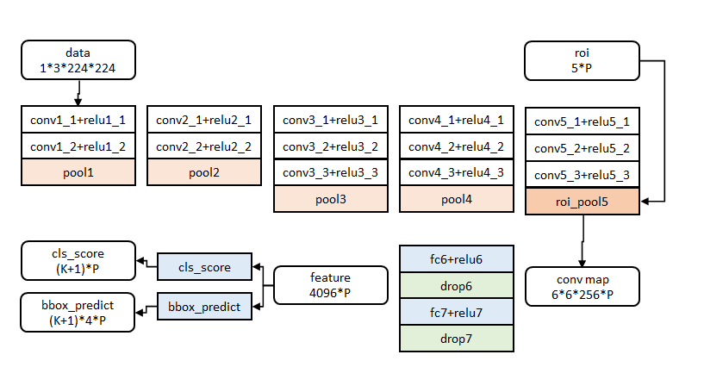

**Figure.7 Basic structure**

The black frame part of the figure.7 is the multi-task loss.

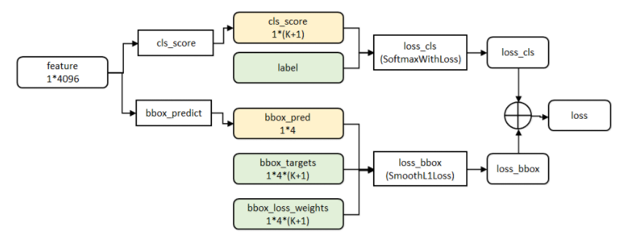

**Figure.8 the structure of multi-task**

**Task 2**

**Problem description**

Please describe the object detection performance metric, mAP (Mean Average Precision), and explain why it can well reflect the object detection accuracy. (20%)

**Results and analysis**

The target detection model is usually trained on a set of fixed categories, so the model can only locate and classify those categories in the image. In addition, the location of the target usually exists in the form of a boundary matrix. Therefore, target detection involves location information and target classification. In target detection, classification and location of models need to be evaluated, and each image may have different categories of targets. Therefore, the standard measure used in image classification cannot be directly applied to target detection that is the reason why we choose Mean Average Precision.

For any algorithm, the measurement is always compared with the true value (Ground Truth) of the data. For target detection, ground truth includes the image, the category of objects in the image, and the bounding box of each target in the image.

The Region Proposal is to find out the possible location of the target in the picture, by using the texture, edge, color and other information in the image to ensure that a higher recall rate (IoU, Intersection-over-Union) is maintained in the selection of fewer windows (thousands or even hundreds).

We need quantifying the correctness of these detection regions. Intersection over Union(IoU) is overlap rate, which was made by the target window generated by the model and the original markup window. Finally, IoU is a kind of standard for measure the correctness of a given border. In other words, IoU defines the overlap of two bounding box.

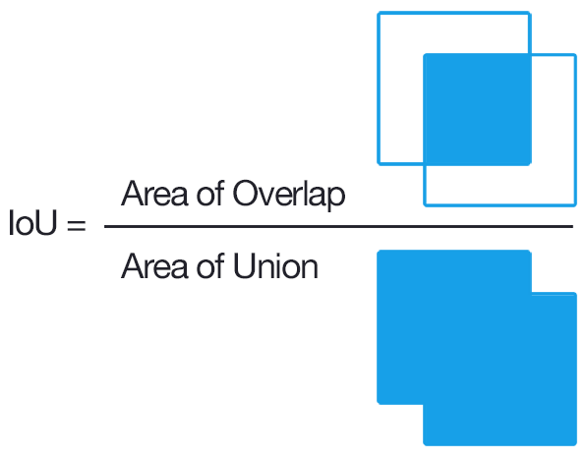

**Figure.9 Computing the Intersection of Union is as simple as dividing the area of overlap between the bounding boxes by the area of union**

The calculation of IoU can have shown in the follow, when IOU equals to 1 that is the ideal situation

$$IoU=\frac{DetectionResult∩GroundTruth}{DetectionResult∪GroundTruth}$$

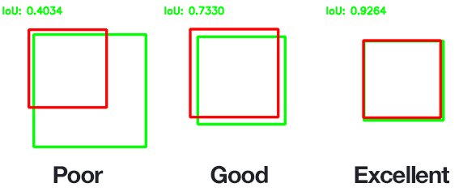

**Figure.10 An example of computing Intersection over Unions for various bounding boxes.**

If we assume the number of IoU equals to 0.5. And then, if $loU>0.5$, that named true detection. If not, that named false detection.

**Table.3 The relationship of TP, FP, FN and TN**

|  |  |  |
| --- | --- | --- |
|  | Relevant | NonRelevant |
| Retrieved | true positives (TP) | false positives (FP) |
| Not Retrieved | false negatives (FN) | true negatives(TN) |

According to table.3, we can get the following function and figure.11

$$Precision=\frac{TP}{(TP+FP)}$$

$$Recall=\frac{TP}{(TP+FN)}$$

$$False positive rate =\frac{FP}{(FP+TN)}$$

$$False alarm =\frac{FP}{(FP+TP)}$$

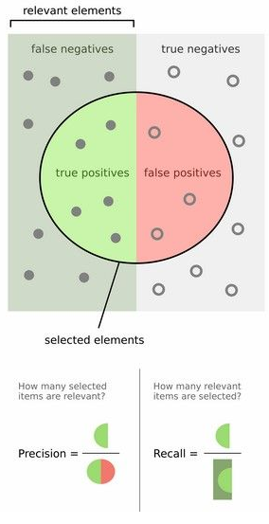

**Figure.11 Precision and recall**

For example, Assume the $class=cat,dog,human$. And then, AP(class)=[AP(cat), AP(dog), AP(human)]. So, Map= $\frac{sum(AP)}{count(AP)}$. The PR curve as shown in the figure.12, the value of AP equals to the area of the graph, which made by PR curve and the Y axis of the X axis

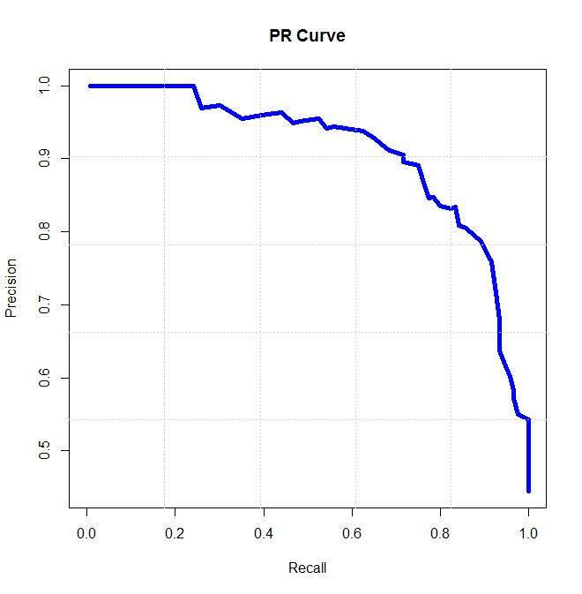

**Figure.12 PR curve**

**Task 3**

**Problem description**

Please train and test the Fast R-CNN framework on one of the existing pedestrian detection datasets, and report the final mAP performance that you have achieved. The dataset could be Caltech [2], INRIA [3], KITTI [4]. Please also report some pedestrian detection examples by including the images and bounding boxes. (40%).

**Experimental process**

The rough procedure of this task can be divided into 2 parts. The first part of this task is to configure and run the Demo and second part is training our own dataset using Faster-RCNN.

Configure and run the Demo

This process mainly uses the instructions on GitHub to configure the environment (<https://github.com/rbgirshick/py-faster-rcnn/blob/master/README.md>). And then, used that to familiarize the process of target detection with Faster-RCNN.

Training our own dataset using Faster-RCNN.

Firstly, there are several brief introductions of engineering catalogue.

(1) Caffe-fast-rcnn: The directory of caffe framework

(2) Data: This file is used to store models for readiness training, cache for reading files, and some scripts for downloading models.

(3) Experiments: This file is used to store the configuration files and the running files, which format is log. In addition, there are scripts in this directory, which contains two kinds of training methods for end-to-end and alt_opt.

(4) Lib: This file is used to store some Python interface files. Such as datasets is mainly responsible for reading the dataset, config is responsible for some configuration options of training.

(5) Models: There are three model files, small network named ZF, medium network named VGG_CNN_M_1024, and large network named VGG16. According to your hardware conditions to choose which network can be used by yourself. ZF and VGG_CNN_M_1024 need at least 3G memory, VGG16 needs more memory, but it will not exceed 11G.

(6) Output: Here is the output directory after training. This directory will appear after training.

(7) Tools: This file contains Python files for training and testing.

For this task, I used VGG16 network, to train the dataset, the structure of that as shown in the figure.13

The first part of training is we should prepare the dataset that named Caltech, this dataset was provided by <http://www.vision.caltech.edu/Image_Datasets/CaltechPedestrians/>.

For this assignment, all tars packages are preloaded to /DataA/PublicDataSet/LAB2 and can be copied that with

cp -r /DataA/PublicDataSet/LAB2

This dataset is mainly included two parts, the first part is training set and testing set, which format is seq. And the second part is label data of pedestrian, which format is vbb (video bounding box). The format of this data is the bounding box of pedestrian in the first dataset. Firstly, I download all of the files, which format is TAR and unzip the files manually. After that, I get the new files, which format is seq.

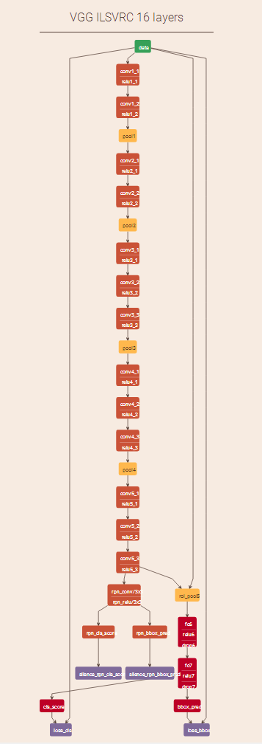

**Figure.13 The structure of VGG-16**

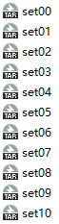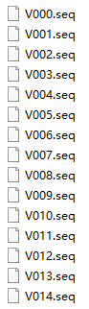

**Figure.14 Dataset (the left is the original files and the right is unzip files)**

And then, I get the video sequences and annotations. Firstly, there are two scripts, convert_seqs.py and divide.py, any one of that can get each frame of the picture.

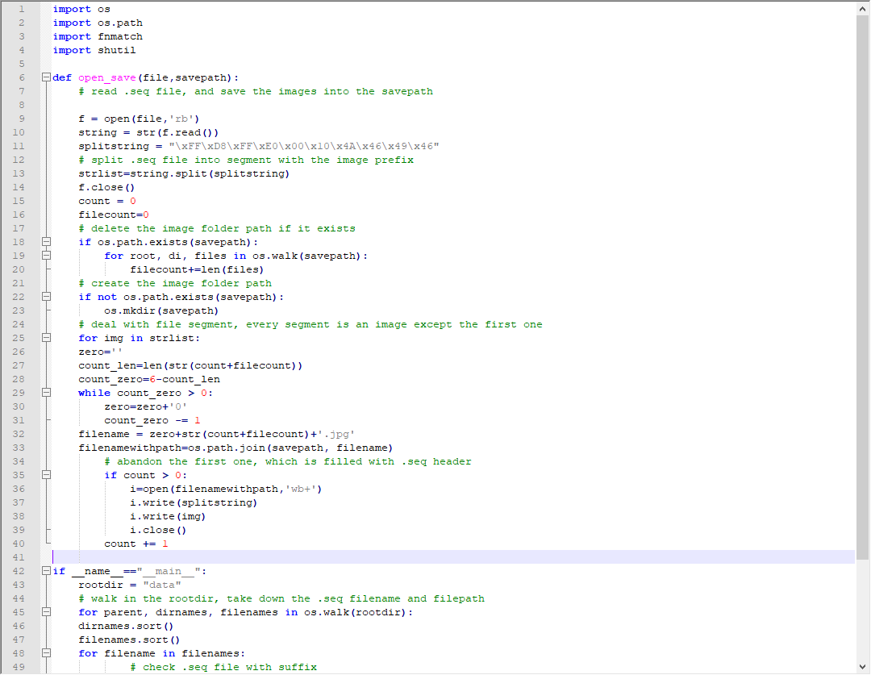

**Figure.15 Details of divide.py (1)**

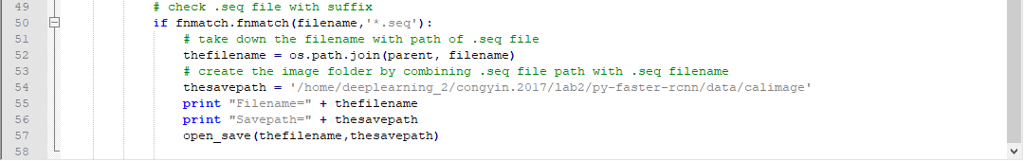

**Figure.16 Details of divide.py (2)**

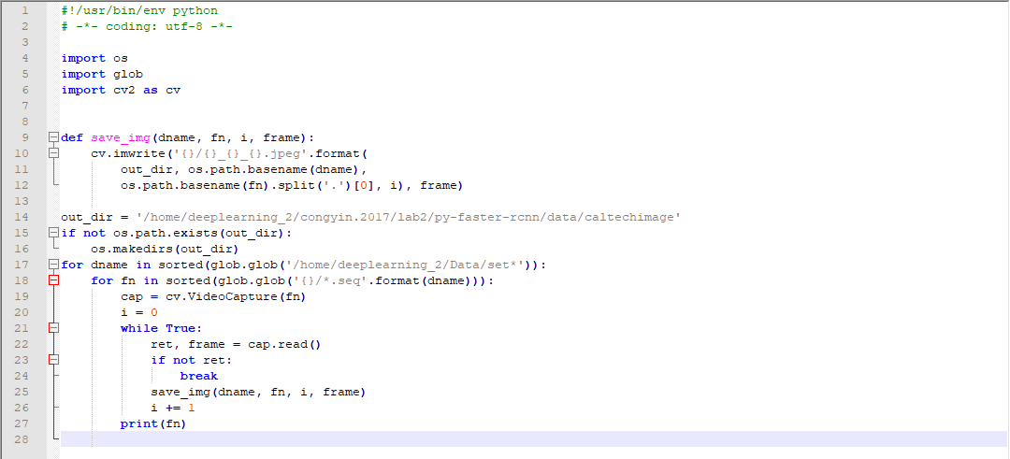

**Figure.17 Details of convert_seqs.py (2)**

Secondly, the matlab script can make the annotations.

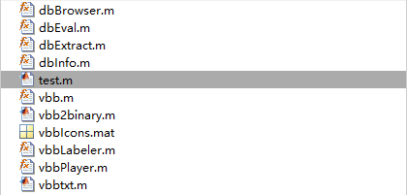

**Figure.18 matlab script**

Run the test.m will transform the format of vbb to txt as shown in the follows.

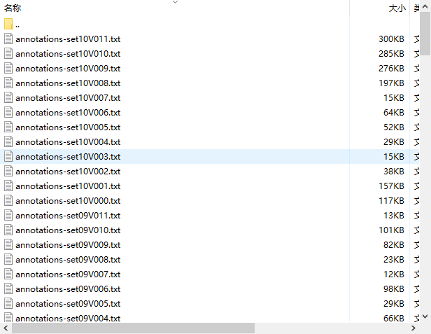

**Figure.19 The examples of annotations, which has been transformed**

Fourthly, run the create_xm.py will transform the format of txt to xml as shown in the figure21 to figure 25. This txt includes the information of picture. And the final step, I run the train.py will transform the format of xml to txt, which different from the first format. There are four datasets, the train and test of that can be used by us

The second part of training is modifying the network structure. Actually, for this part, we just modify a small amount of content. I only changed the number of iterations as shown in the figure.20

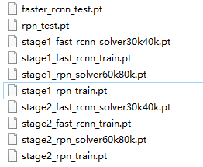

**Figure.20 network structure**

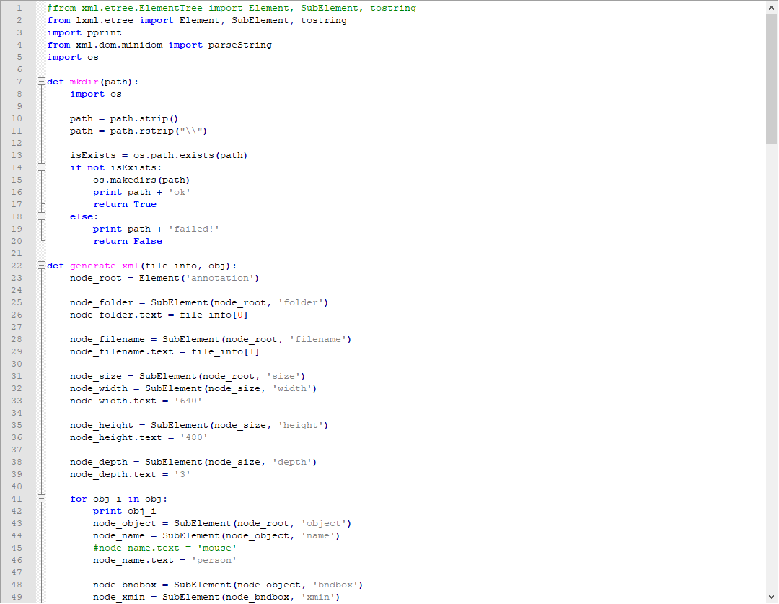

**Figure.21The details of create_xm.py (1)**

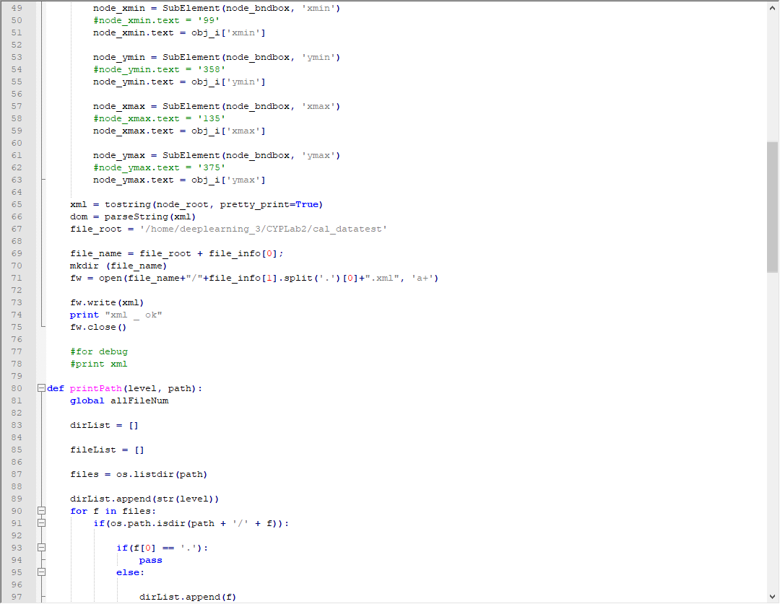

**Figure.22 The details of create_xm.py (2)**

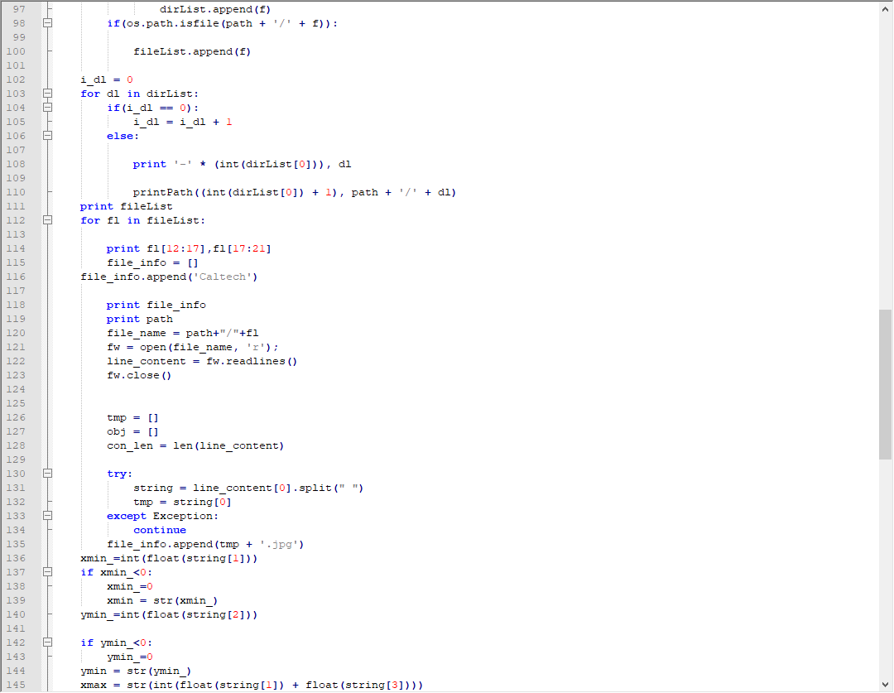

**Figure.23 The details of create_xm.py (3)**

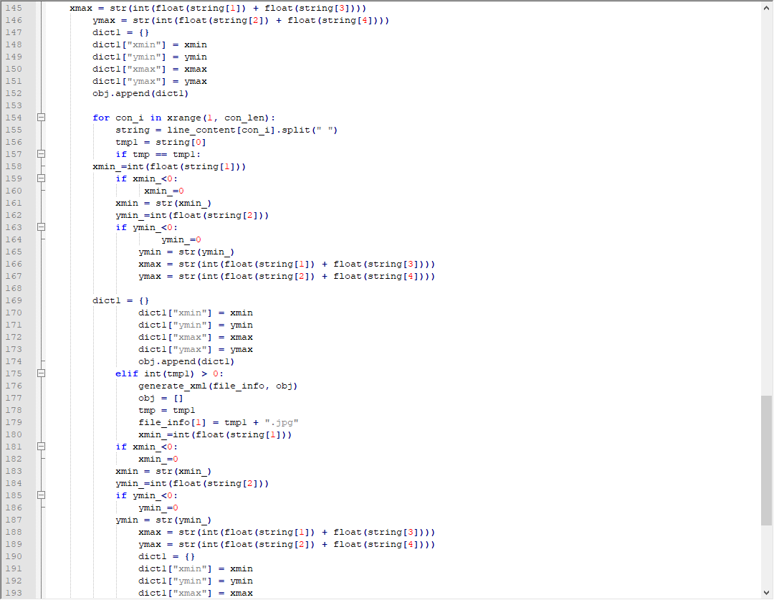

**Figure.24 The details of create_xm.py (4)**

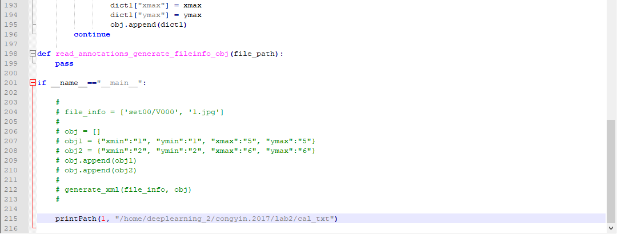

**Figure.25 The details of create_xm.py (5)**

The third part of training is change the interface, I changed something of pascal_voc.py and rename it to caltech.py. There are only two categories, person and background, so relevant codes should be changed.

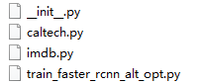

**Figure.26 These scripts will be used for accessing the data**

Finally run the faster_rcnn_alt_opt.sh we can get the results and I randomly choose four pictures as shown from figure27 to figure.30.

**Results and analysis**

The map of this task is 56.73%. According to the figure 27 to figure 30, we can see the red box and green box. The score of red box is higher than green box. In addition, there are also red and green boxes with similar scores in some examples. That means poor performance.

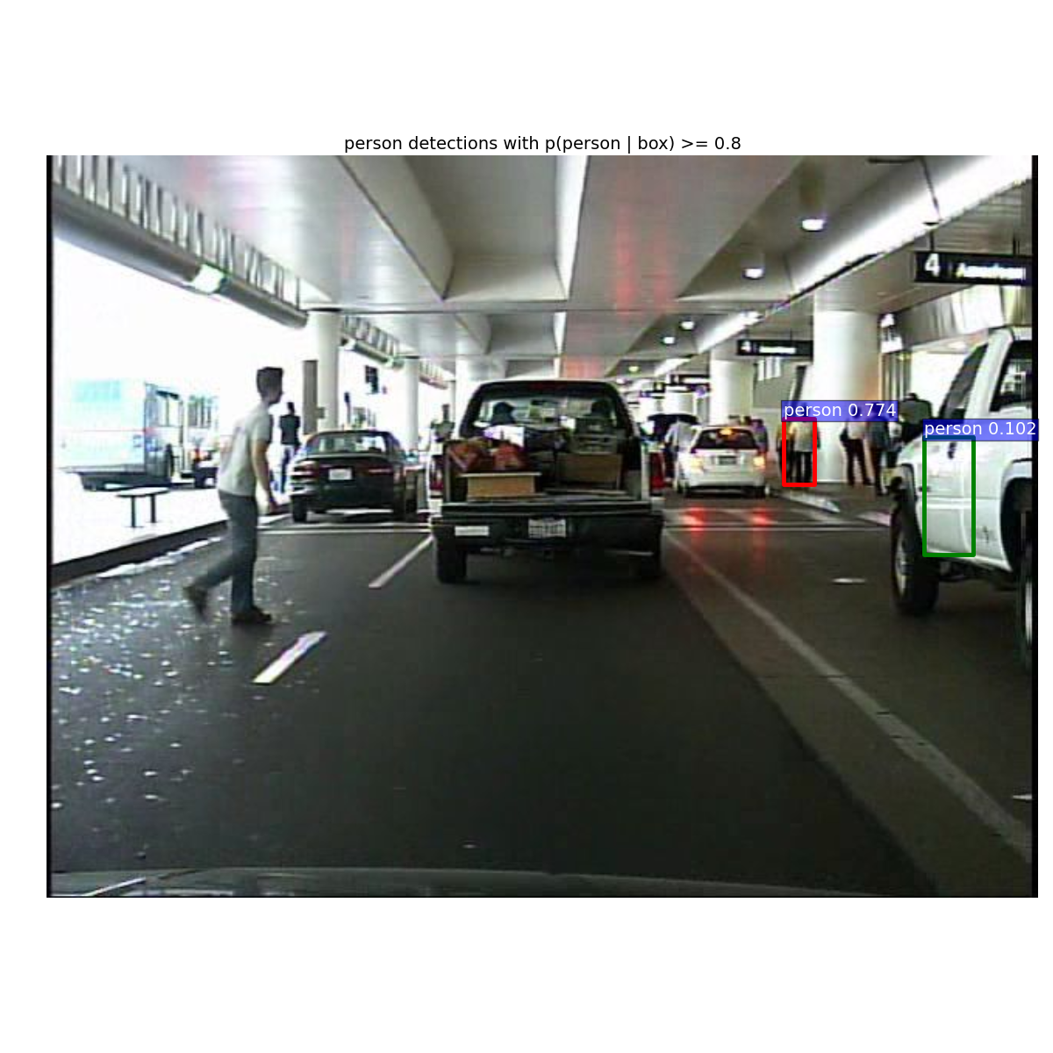

**Figure.27 results (1)**

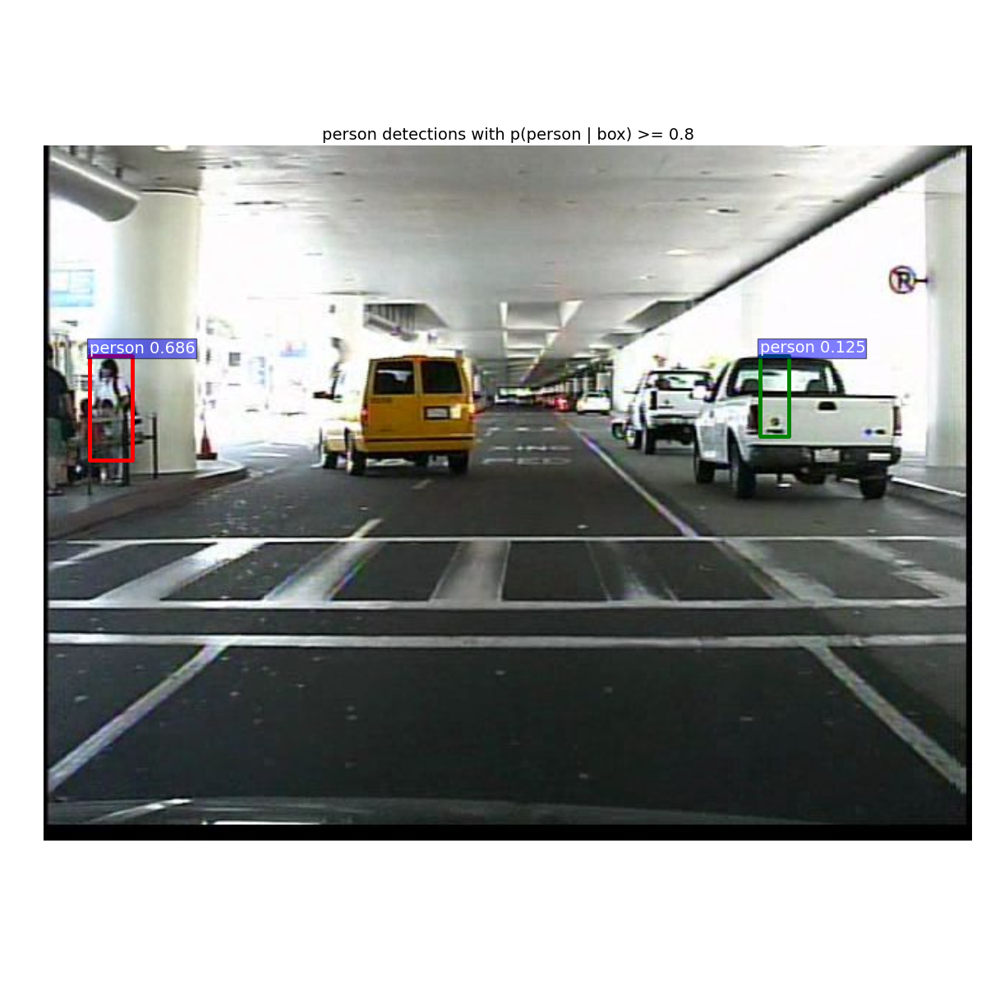

**Figure.28 results (2)**

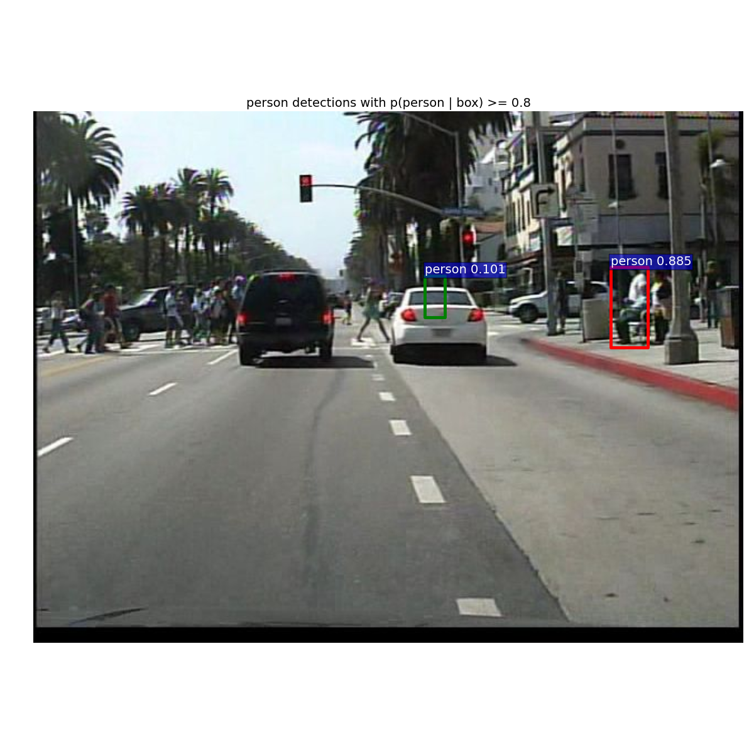

**Figure.29 results (3)**

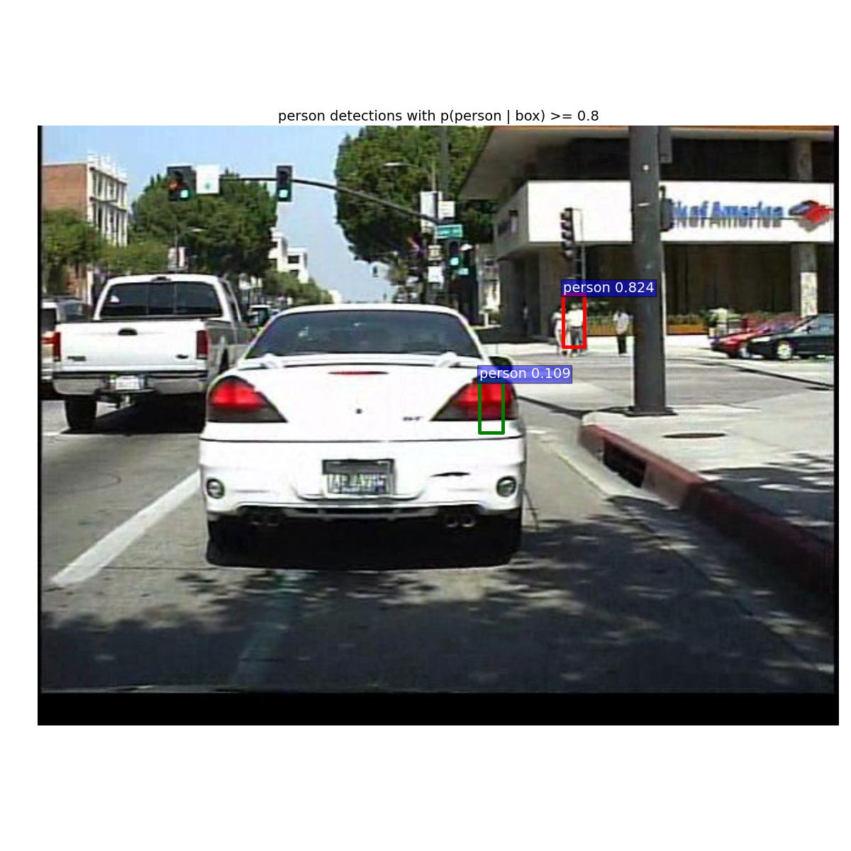

**Figure.30 results (4)**

**Task 4**

**Problem description**

Propose your own method to further improve the pedestrian detection performance based on the Fast R-CNN framework. (20%)

**Results and analysis**

We try to convert VGG-16 to any layers of ResNet, that is not a very difficult procedure. For this task, we use ResNet-50 to replace the VGG-16. The results as shown from figure.31 to figure. 34. Because of we just replaced the network structure violently, so the MAP is lower than original Faster R-CNN, which network structure is VGG-16. Due to timing, we not try to modify more details parameters of network. However, that is a kind of direction of improvement. It just need to change more details, such learning rate and interation.

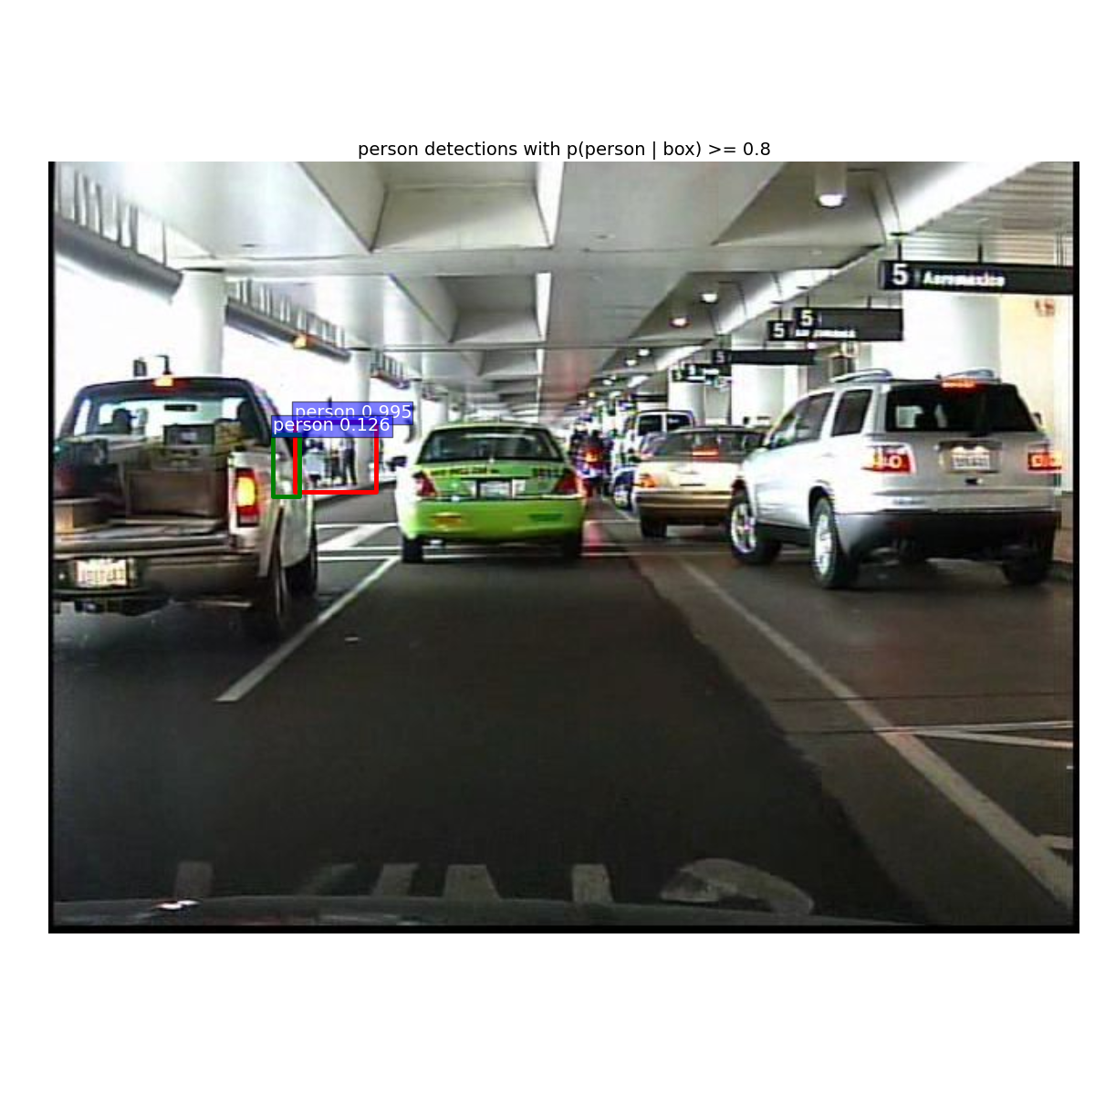

**Figure.31 ResNet-50 results (1)**

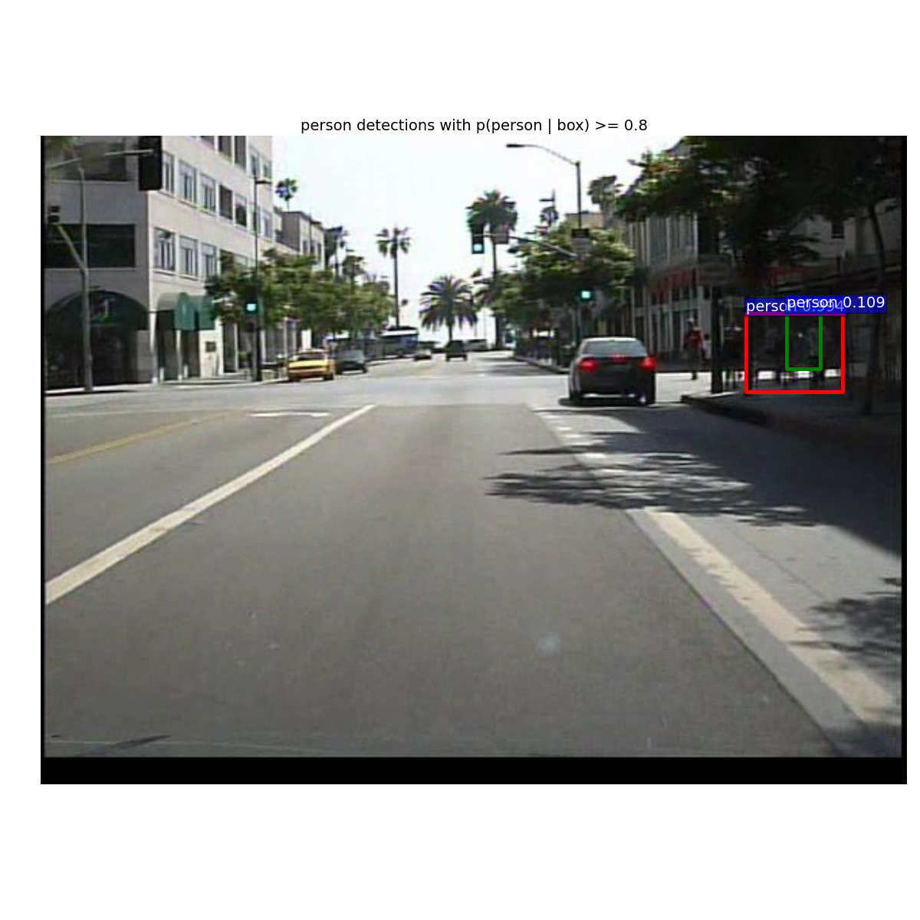

**Figure.32 ResNet-50 results (2)**

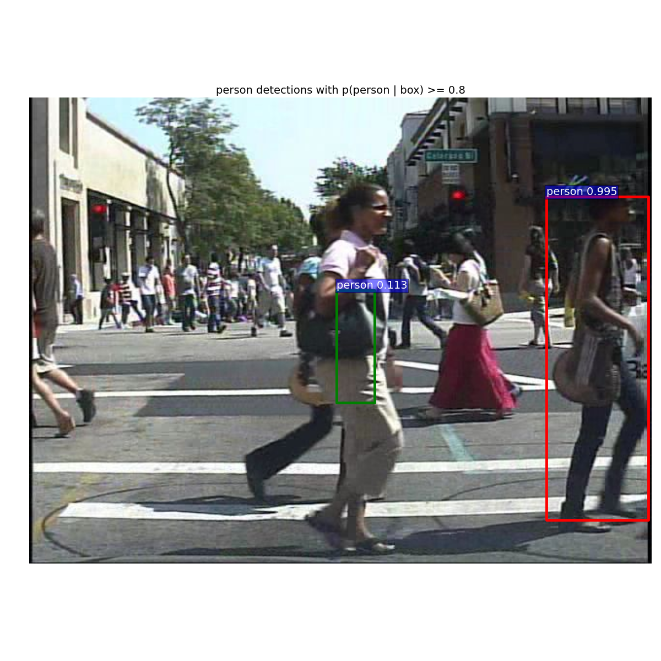

**Figure.33 ResNet-50 results (3)**

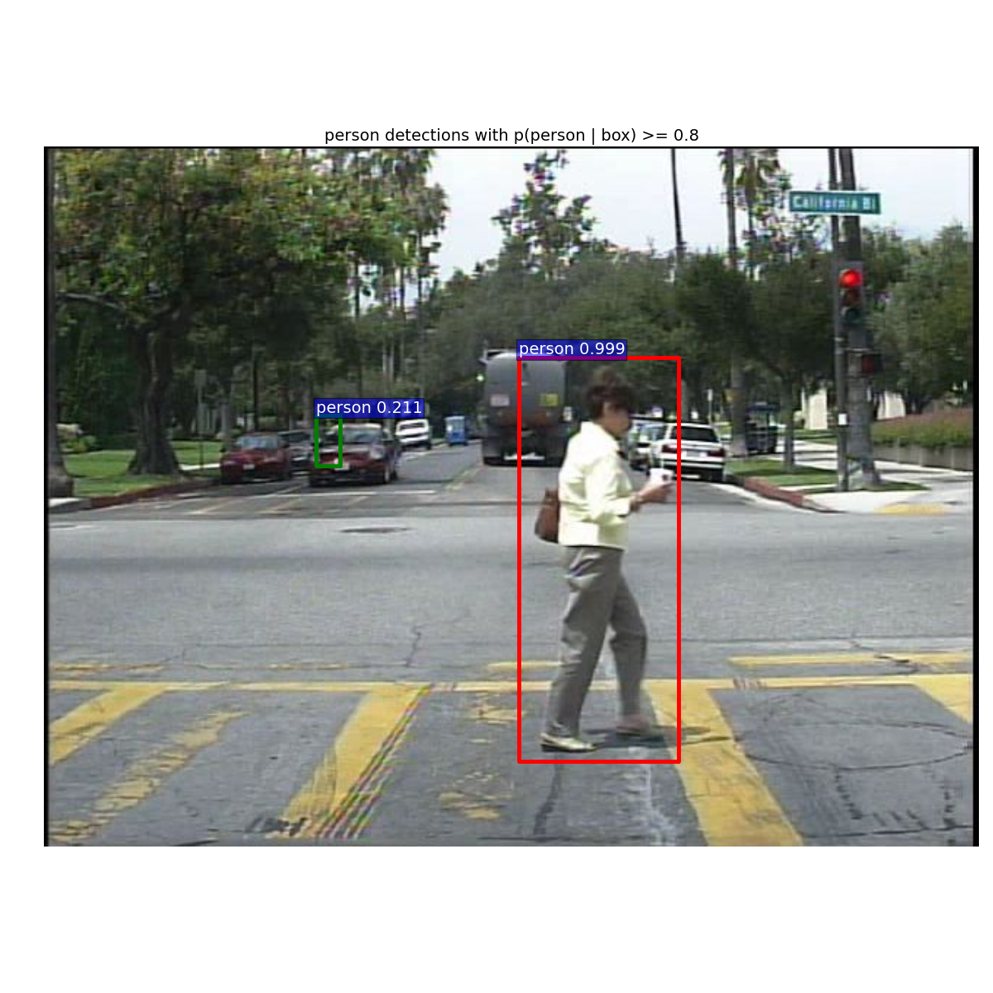

**Figure.34 ResNet-50 results (4)**

**Conclusion**

For this assignment that gives us a deep understanding of RCNN and its derived models. According to a series of processes, which include configure the network environment, replace the dataset, modify the network files and modify the interface that can access the data to the network.

**Reference**

GIRSHICK, R. Fast R-CNN. IEEE International Conference on Computer Vision, 2015. 1440-1448.

LI, J., LIANG, X., SHEN, S. M., XU, T., FENG, J. & YAN, S. 2015. Scale-aware Fast R-CNN for Pedestrian Detection. *IEEE Transactions on Multimedia,* PP**,** 1-1.

REN, S., HE, K., GIRSHICK, R. & SUN, J. Faster R-CNN: towards real-time object detection with region proposal networks. International Conference on Neural Information Processing Systems, 2015. 91-99.